**1. Advanced Network Simulation**

1. Create a small 5G network with two base stations and 10 UEs.

In teacher’s [tutorial](https://www.dropbox.com/scl/fo/2x667pyue3qj7pyta6icv/AHyREEjiXOMkJ7qbH9Hc4fg/Ns3Tutorials?dl=0&preview=NS3-examples.pdf&rlkey=0mvwq85suwh9phb01e60dz7j3&subfolder_nav_tracking=1), he run this to set a simple 5G network. We key --PrintHelp for getting information of parameters.(Fig. 1) By reading the description, we can set gNbNum to two and ueNumPergNb to ten to satisfy the problem and get what we want.(Fig. 2)

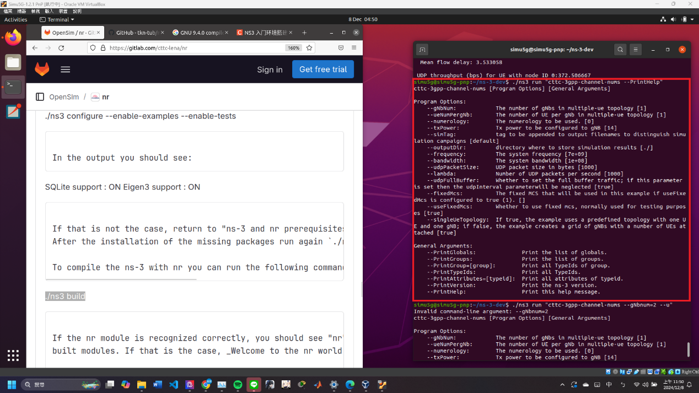

Fig. 1

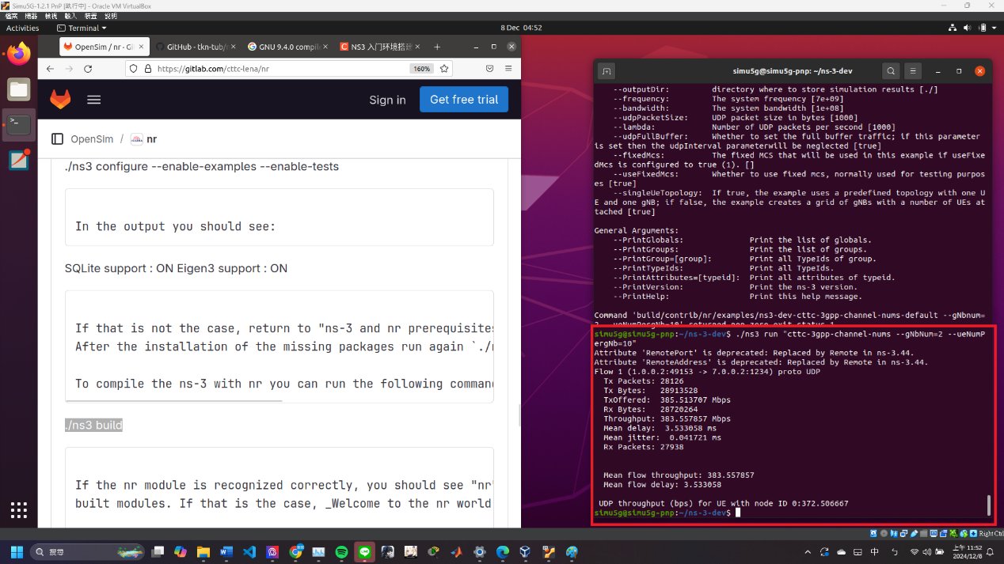

(Fig. 2)

1. Test an application (in examples/test folders) and validate its throughput, delay, jitter metrics.

Here we choose cttc-nr-mimo-demo to test. We also key –PrintHelp for getting information of parameters.(Fig. 3,4) By reading the description, we choose txPowerGnb to test what are the different results for different txPowerGnb. We set txPowerGnb to 20, 25, 30, 35, 40 respectively. (Fig. 5~7)

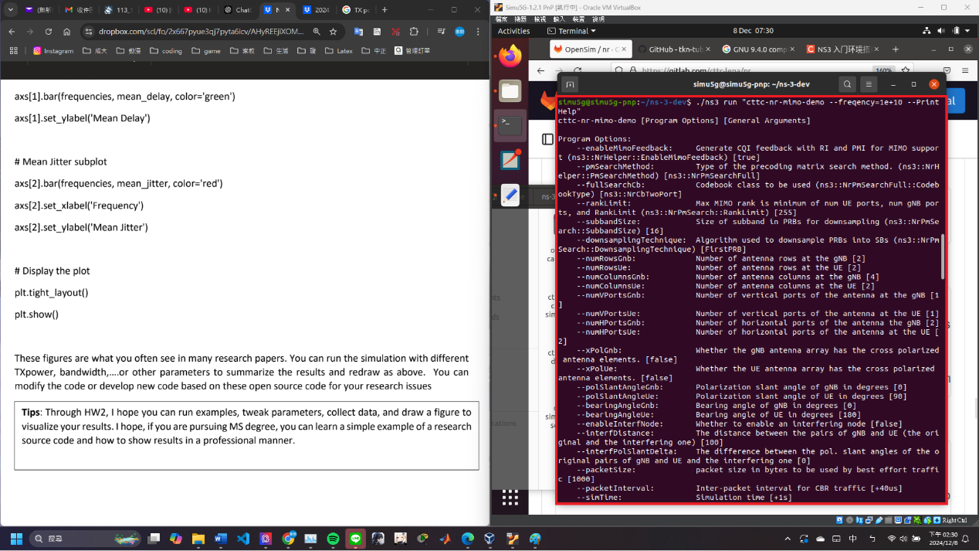

(Fig. 3)

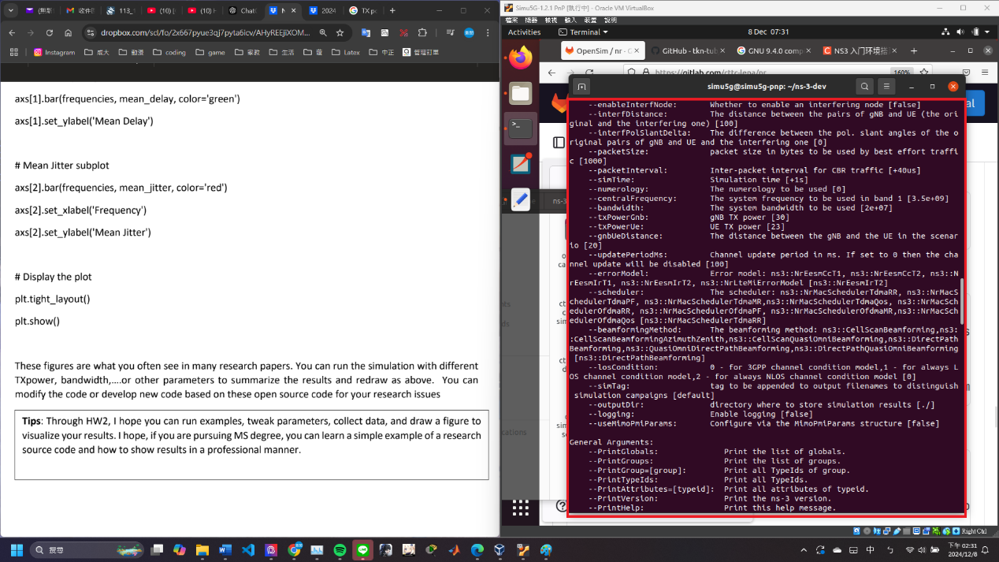

(Fig. 4)

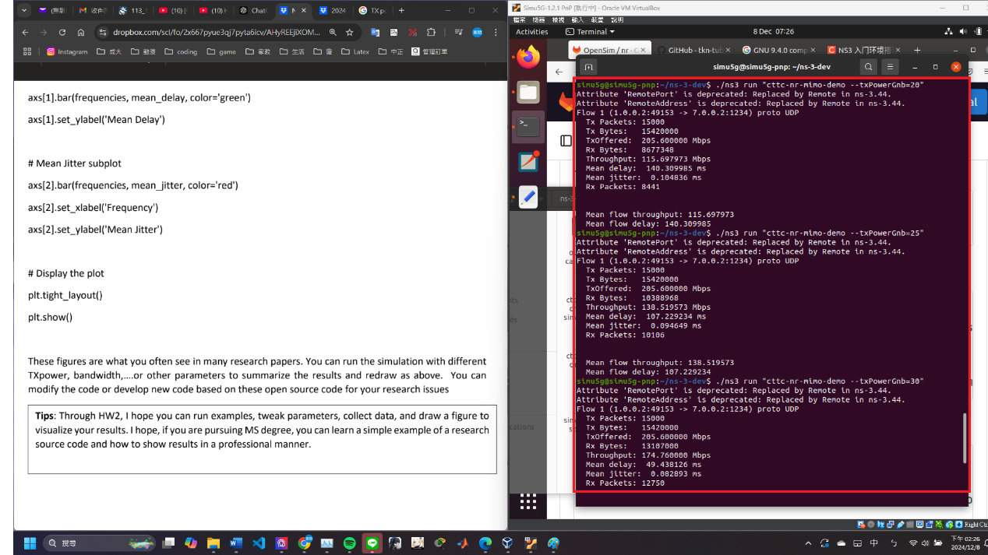

(Fig. 5)

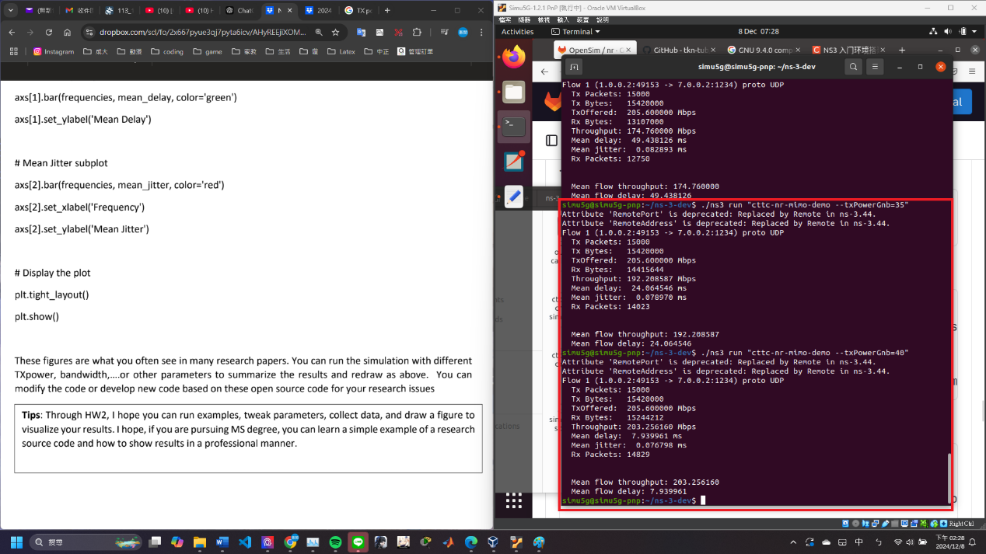

(Fig. 6)

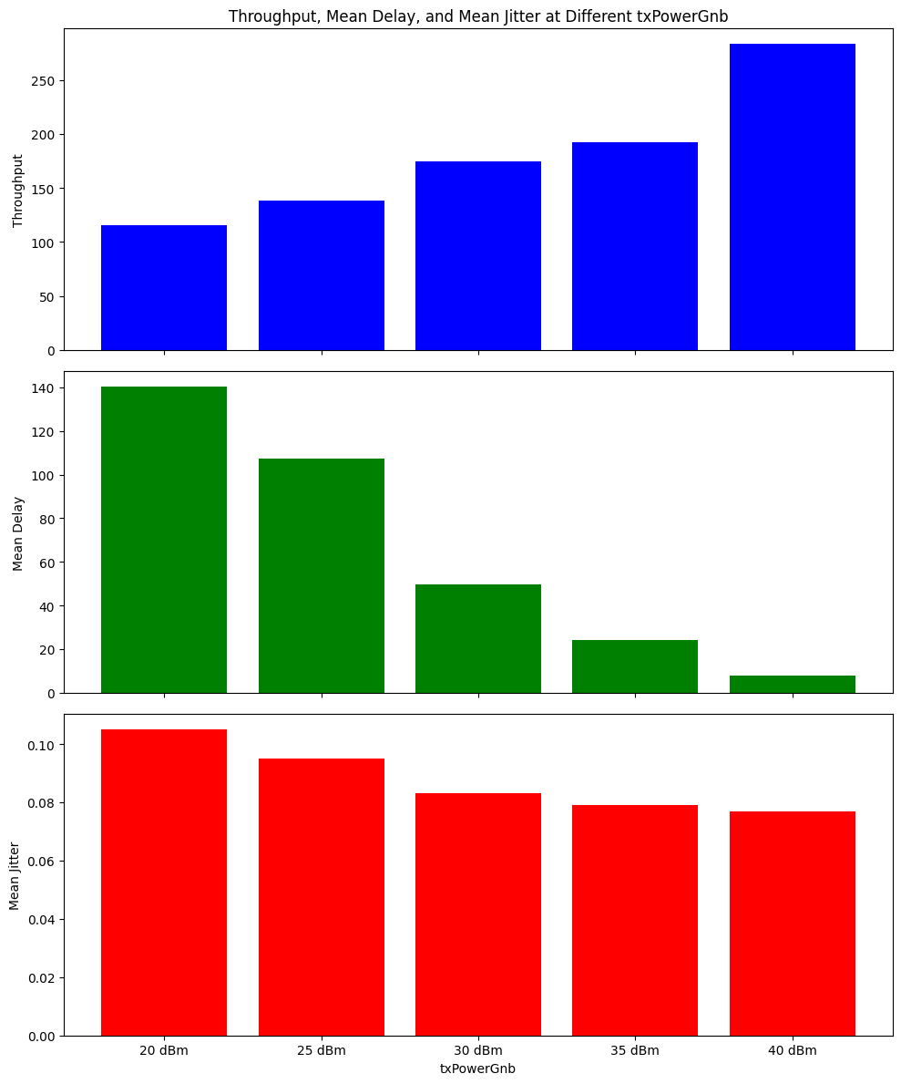

(Fig. 7)

1. **Congestion control and network security**
2. **Firewall configuration**

* Deny all FTP connections from outside to access NYCU FTP servers

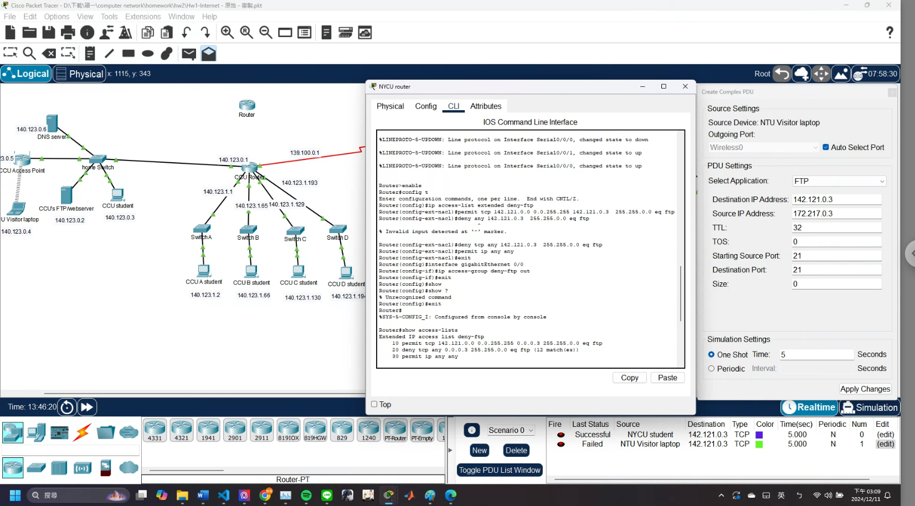

(Fig. 8) install

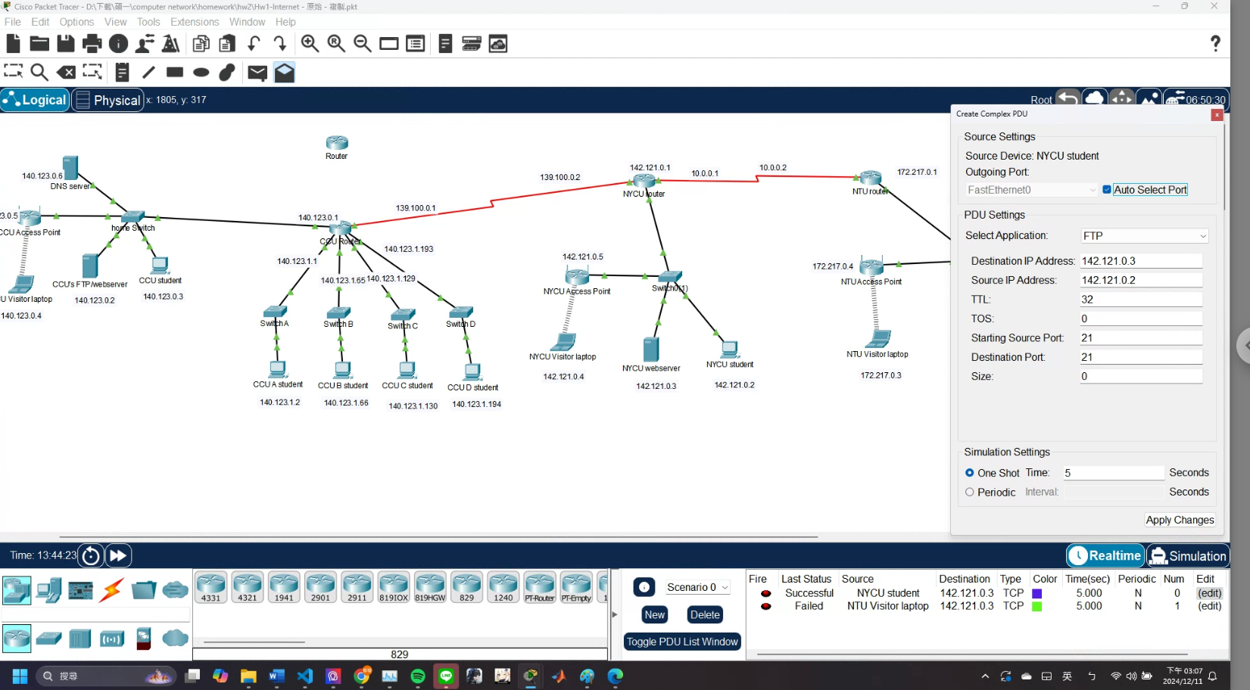 (Fig. 9) test from NYCU student

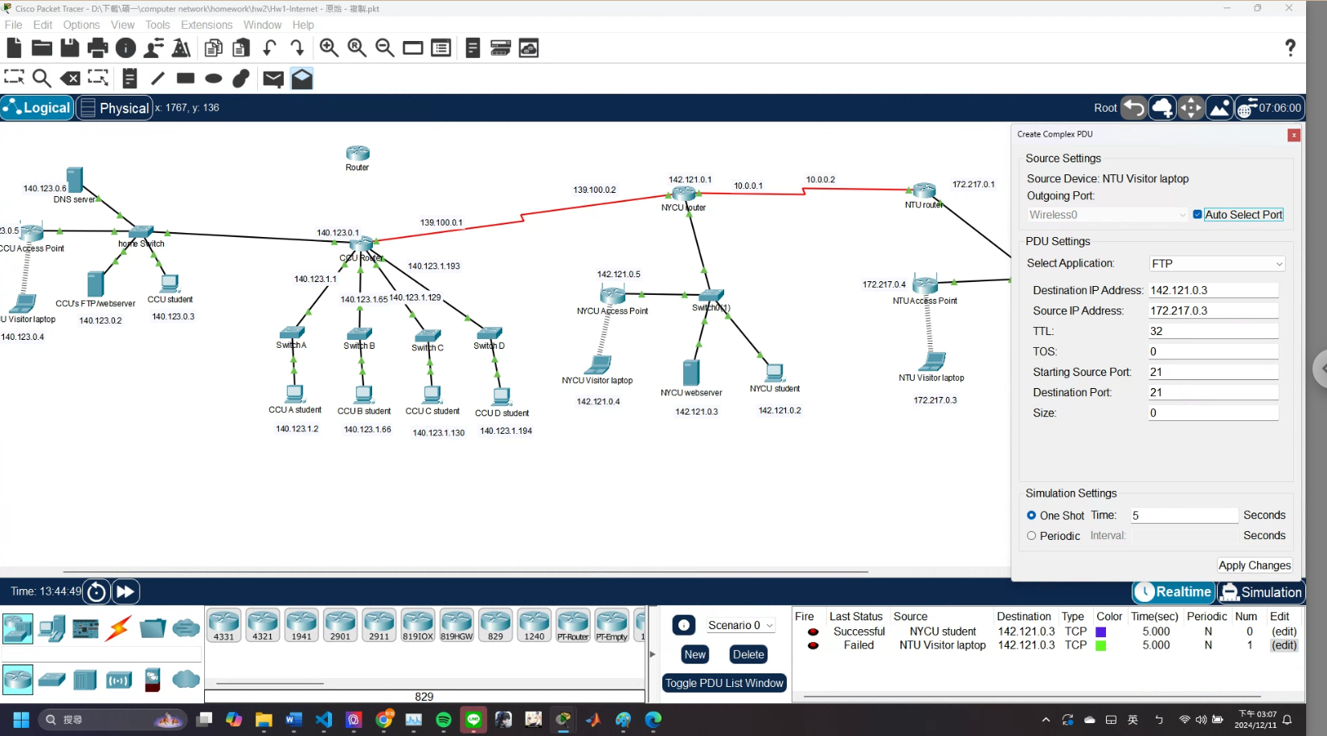

(Fig. 10) test from NTU Visitor laptop

We install(Fig. 8) and test(Fig. 9, 10).

* Deny all remote control (SSH) connections from outside to access CCU server

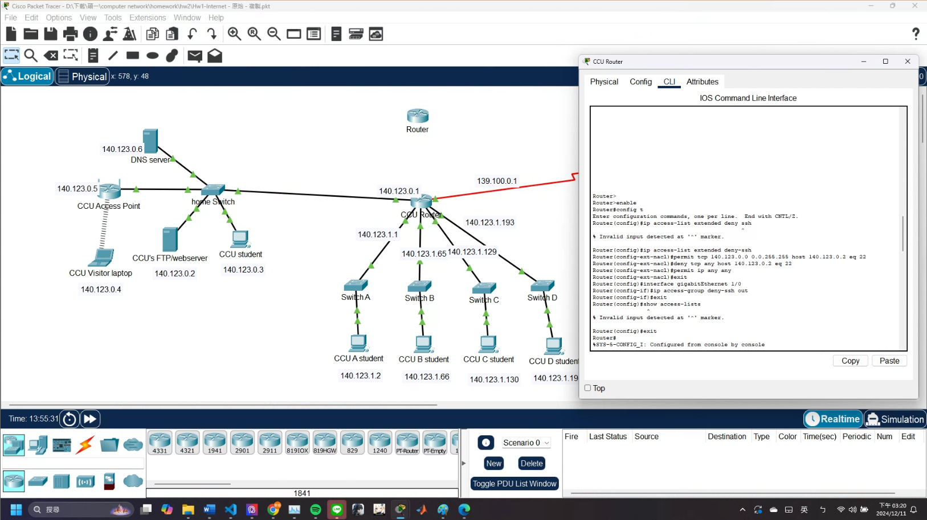

(Fig. 11) install

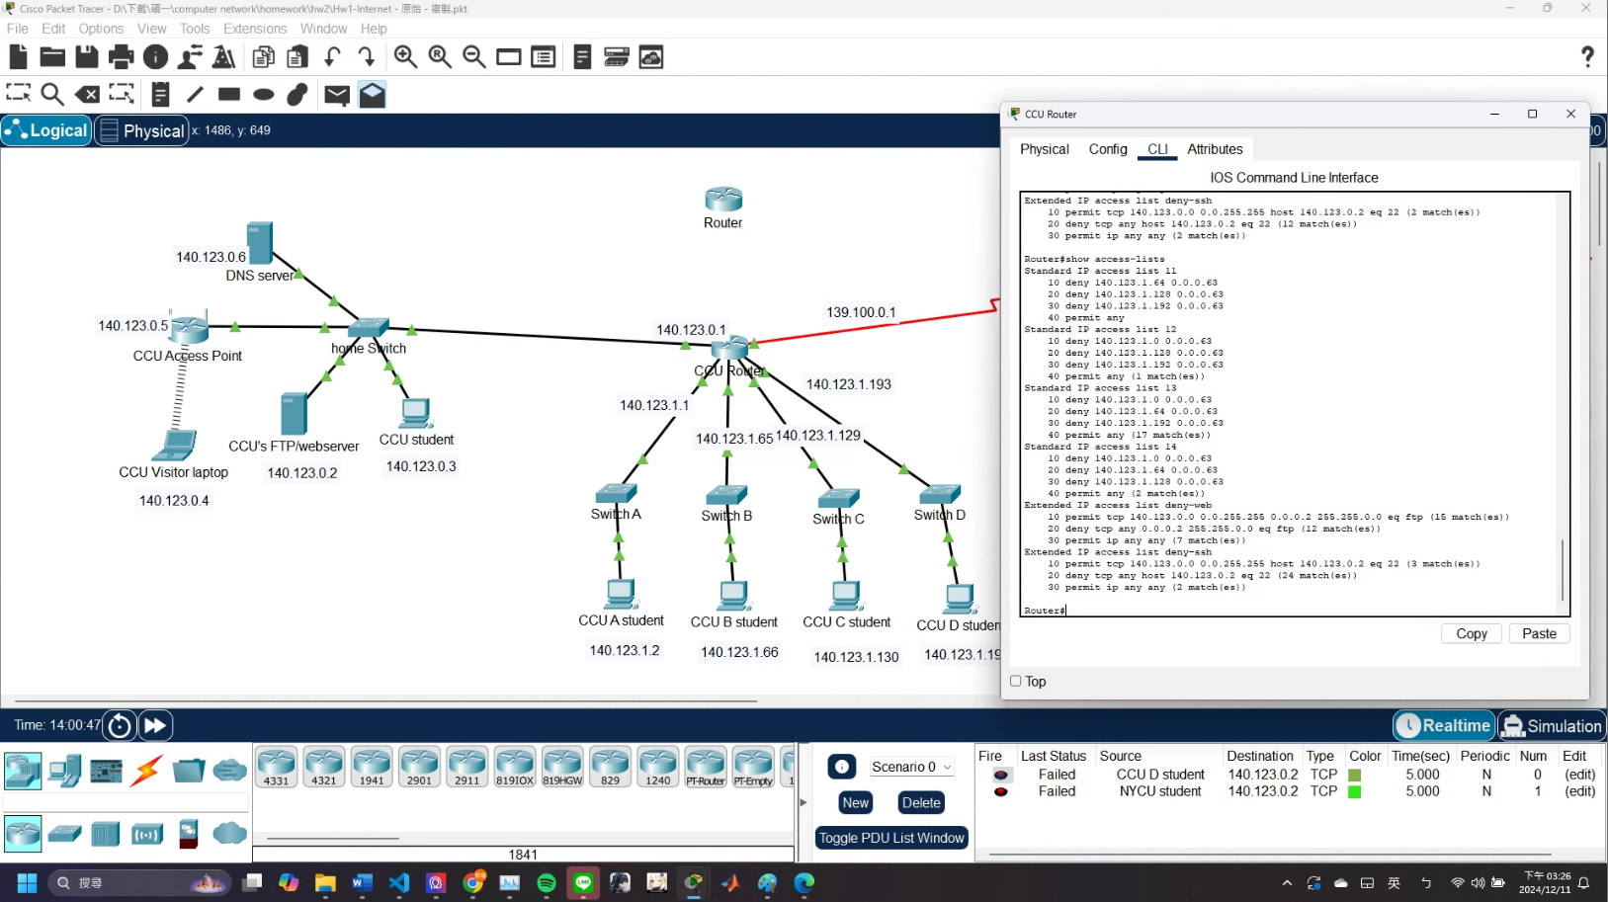

(Fig. 12) origin state

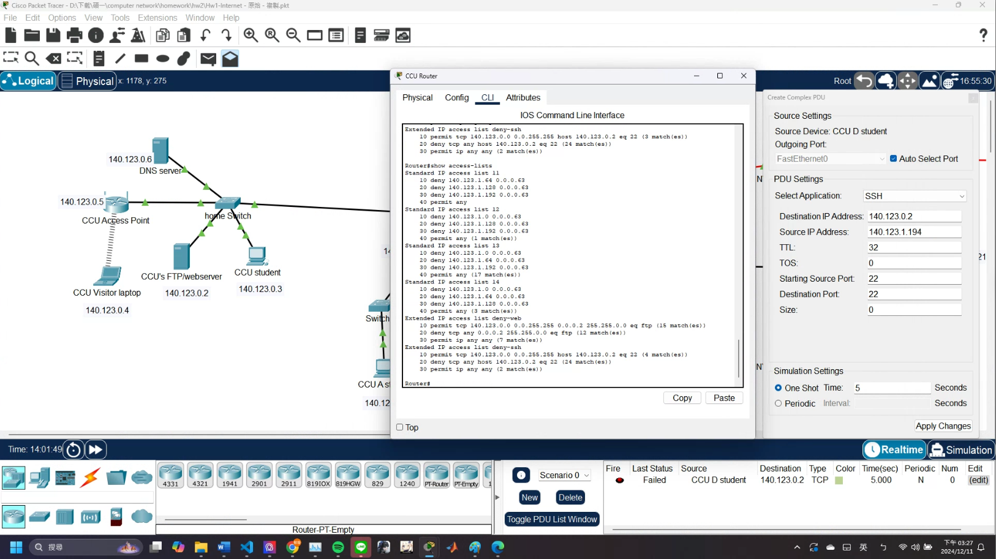

(Fig. 13) test from CCU D student

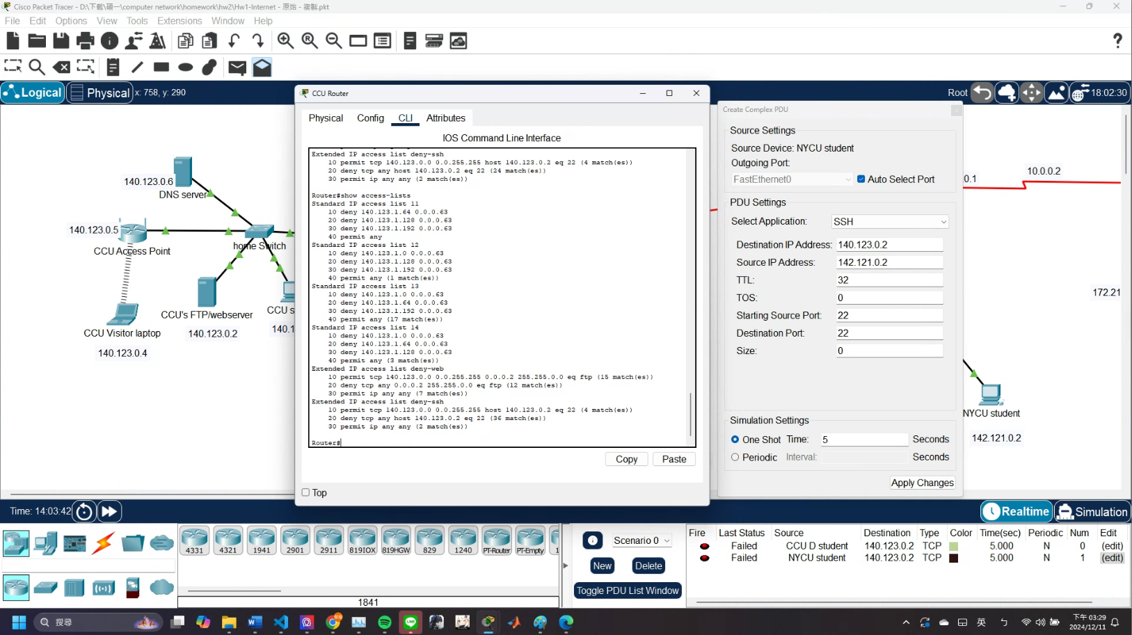

(Fig. 14) test from NYCU student

We install(Fig. 11) and test(Fig. 12~14). Last status is failed because ccu server can’t be ssh server, it can’t response to the request. In the test screenshots we can see the ACL can actually permit and deny!